**SRM Institute of Science and Technology**

**Workbook on**

**18LEM110L INDIAN ART FORM**

**MODULE 1**

**Session 1- SLO 1**

**Ancient India: An Overview**

Ancient India is the Indian subcontinent from prehistoric times to the start of Medieval India, which is typically dated to the end of the Gupta Empire. Ancient India was composed of the modern-day countries of Afghanistan (some portions), Bangladesh, Bhutan, Myanmar, India and Pakistan. There are a host of resources available to enrich your knowledge about the general history, culture, science and technology and organizations concerned with ancient India. The following exercise consists of a set of questions to enable you check you knowledge about various facts pertaining to the society and culture of Ancient India.

Identify the correct answer(s) for following questions from the choices given below them. There can be more than one correct answers for a question. Discuss the answers with your class and justify your choices. Added spaces have been provided with some questions for additional opinions.

Q.1 Why do you think settlements happened in the Indus River Valley?

1. to be safe during the draught
2. for irrigation, transportation, trade, communication
3. to enjoy the nature’s bounty
4. Elder members of communities wished to

 Q.2 identify the two major rivers of Ancient India from the following -

1. Tigris & Euphrates
2. Nile & Blue Nile
3. Indus & Ganges
4. Huang He & Yangtze

Q.3 Why do you think Indians eagerly waited for summer monsoons?

1. They brought rain & without them there would be drought
2. The cold winds were soothing during harsh summer
3. Monsoon helped in travels across the rivers
4. Monsoons made the pastures green

 Q.4 After giving up the nomadic lives, what occupations did Aryans adopt for living?

1. constructing palaces
2. accumulating arms
3. farming
4. animal husbandry

Q.5 The Indian literature focused on

1. war; brave warriors & their heroic deeds
2. home life
3. politics & government
4. holy writings & Hindu themes

Q.6 Identify the written language of the Ancient Indian civilization -

1. cuneiform
2. Sanskrit
3. hieroglyphics
4. Hindi

Q.7 The four classes (varnas) in the Indian caste system are known as:

1. Pharaoh, priests, artisans, slaves
2. Brahman, Kshatriyas, Vaisyas, Sudras
3. King, queen, princes, lords
4. Shogun, samurai, governors, artisans

Q.8 Which one of the following is a social group in which one is born and cannot change it afterwards -

1. religion
2. family
3. tribe
4. caste

Q.9 Which things were decided based on a person's caste?

1. Job, marriage, friends
2. Foods
3. Clothes
4. Rituals and ceremonies

Q.10 What were the influences behind building temples, art and sculptures?

1. Happiness and devotion
2. Religion
3. Sacred knowledge and texts
4. Caste

 Q.11 Identify India's two most notable epics among the following -

1. Odyssey & Iliad
2. Mahabharata & Ramayana
3. Vedas & Upanishads
4. Enlightenment & Nirvana

Q.12 Why do you think Indians never challenged the caste system?

1. It became associated with religious beliefs.
2. The economy depended on it.
3. They were afraid banishment.
4. They grew accustomed to the class they were born into.

Q.13 Reincarnation is...

1. a state of spiritual communion with God
2. taking another birth for fulfilling a duty
3. the payback for previous life
4. performing the duties of the caste

 Q.14 Nirvana is...

1. a state of attainment of supreme knowledge
2. taking a rebirth to be united with Brahman
3. the blissful state
4. the divine law

Q.15  Karma is...

1. hard work
2. Yogic practice
3. the consequences of person’s deeds
4. the duties of peopleQ.16 Dharma is...
5. wisdom
6. Salvation
7. Devotion
8. the divine law

 Q.16 The holy books of Hinduism are -

1. Torah & the Bible
2. Vedas & Upanishads
3. Book of the Living & Book of the Dead
4. Old Testament & New Testament

Q.17 How do you think Hinduism primarily spread across the Indian subcontinent? Give reasons.

1. through cattle
2. through rivers
3. trade, travel, and war
4. through deserts

________________________________________________________________________________________________________________________________________________

Q.18 What did King Ashoka help spread by building roads, hospitals, and shrines? Include your opinions on his philosophical beliefs.

1. Hinduism
2. Buddhism
3. Christianity
4. Islam

________________________________________________________________________________________________________________________________________________

 Q.19 During the Gupta dynasty, the contributions by Indian mathematicians included -

1. algebra, addition & multiplication
2. 365-day calendar, fractions, hieroglyphics
3. algebra, zero, & infinity
4. algebra, alphabet, chemistry

Q.20 Which geographical feature marks India as a subcontinent of Asia?

1. Nilgiris
2. Ganges River
3. Himalayan Mountains
4. Thaar Desert

Q.21 Which of the following is not part of the caste system? Write a brief note on India caste system.

1. Brahmans
2. Vaisyas
3. Dalits
4. Sudras

____________________________________________________________________________________________________________________________________________________________

**Session 1- SLO 2**

**Raja-Ravi Varma: religious stories like mythologies of Hindu gods**

Raja Ravi Varma was an Indian painter and artist, considered as one of the greatest painters in the history of Indian art. Varma is known for his amazing paintings, which revolve mainly around the Puranas and the great Indian epics - Mahabharata and Ramayana.Ravi Varma is one of the few painters who managed to accomplish a beautiful union of Indian traditions with the techniques of European academic art. (Source: https://www.tallengestore.com/collections/raja-ravi-varma). Closely observe the following paintings by Ravi Varma and appreciate them from an art critic’s viewpoint in about 100 words.

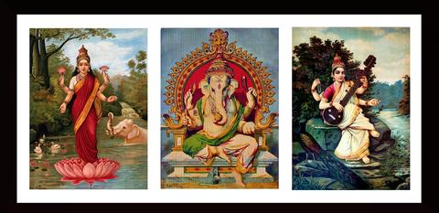

Image 1(Source: https://www.tallengestore.com/collections/raja-ravi-varma)

__________________________________________________________________________________________________________________________________________________________________________________________________________________________________________

**Session 2- SLO 1**

**Mysore and Tanjore Art**

Tanjore painting involves numerous stages, such as meticulous layingout, prefect sketching, elegant ornamenting with stones, intricate embossing work and gold foiling the deities and finally the finishing enrichment. Embossing is done with a mixture of raw lime stone powder sieved through the muslin cloth and mixed with chalk powder, glue and copper sulphate in certain proportion. Gold leaves, semi-precious stones and mirrors are used to give it the grand look. In the olden days gold dust or bhasma was used instead of gold leaves. All the paintings are done with traditionally made gold foils. Colors used for painting are fungus resistant. The painting lasts for generations. There are few differences between Tanjore and Mysore style of Painting. In Tanjore, the gesso work is thicker in comparison to the Mysore painting. They also put wooden cardboard to increase the thickness of gesso layer. That gives it a three dimensional feel. Color stones are used in Tanjore painting. In Tanjore painting, the gold foil used is thick while in Mysore painting the foil is delicate in nature. In Tanjore paintings main subject is to depict the life of Krishna, where as in Mysore Style, theme is Universal. (Source: http://www.dsource.in/resource/mysore-painting/tanjore-and-mysore-painting)

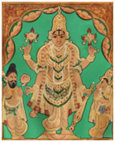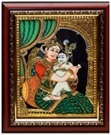

Tanjore Painting Mysore Painting

Image 2 (Source: https://www.gktoday.in/gk/mysore-paintings-versus-tanjore-paintings/)

**Assignment**

Gather relevant facts about Mysore and Tanjore paintings and answer the following questions. Each question contains 5 marks:

Write a brief History of Mysore Paintings.

What is the process involved in making Mysore paintings?

Write the unique feature of Tanjore paintings.

Explain the procedure of Tanjore paintings.

**Session 2- SLO 2**

**Indian artists from different fields**

The history of Indian painting dates back to the era of Ajanta, Ellora and other murals. Other famous examples are Buddhist palm leaf manuscripts, the Jain texts and the Deccan, Mughal and Kangra schools. Indian paintings is a portrayal of tradition and depiction of ancient texts and theories in color and anecdotal accounts. It was common during the ancient times have paintings in households in the doorways or indoor rooms where guests resided.

Cave painting is another example we can refer to know further about Indian paintings. The paintings of Ajanta, Bagh and Sittanvasal and temple paintings testify to a love of naturalism. From the early civilization to the present day the paintings provide an aesthetic continuum. Various traditions that have existed in the country have helped for the evolution of paintings in India.

Miniature paintings are those executed on a very small scale on perishable material such as paper, cloth, etc., though this style had been perfected by artisans under the various rules, not many remain today. Prime examples are the Rajasthani & Mughal miniatures.

Contemporary artists have kept up to the times & excel in their modern works, giving free expression to their imagination & artistic liberty. (Source: https://www.nriol.com/indian-paintings/)

**Classwork**

Collect the images (one for each) for the following kinds of Indian traditional paintings and label them. Paste the images in the space provided below. Adjest the size of your images accordingly.

Madhubani – Rajput – Kalamkari – Pattachitra – Warli (5x5=25 marks)

**Session 3- SLO 1 & 2**

The world’s audience might have certain familiarity with Indian tribal and folk art motifs which often get reproduced through the medium of print on various commodities. However, you might not know the origin of those images that connote and represent an aura of India. Indian art motifs are as diverse as Indian culture itself, but one may still be acquainted with the reappearing symbols of deities, flora and fauna, courtly life and customs among other images which have often been produced by folk artists. (Source: https://theculturetrip.com/asia/india/articles/indian-folk-arts-evolution-and-diversity/)

**Classwork**

Observe the following images carefully and write a paragraph (200 words) on how folk art plays crucial role in the lives of common man in India. (5 marks)

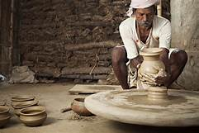 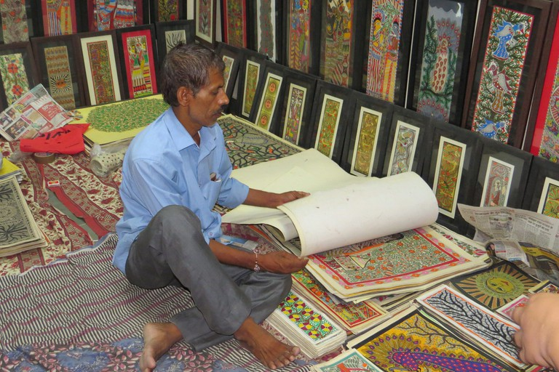 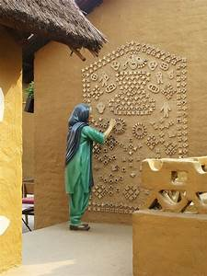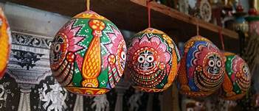

Image 3 (Source: https://images.search.yahoo.com/search/images)

**Session 4- SLO 1 & 2**

Over time Indian art has been host to a lot of emotions, mythological significance, and cultural representation. And while it has been representing all this, one of the most controversial yet surreal Indian art is modern art which has been revolutionizing us and the entire world since the nineteenth century. Some of the greatest artists have since then been representing our heritage and our ethos through the medium of canvas painting. Illustrating even the most complex of situations and feelings with the stroke of their brushes and under the layer or the oil paints. Indian art paintings have moved away from being beautiful and skilled to gorgeous and insightful. They started moving from traditional art to modern art and then to contemporary art. The well renowned artists as well as the new genre one’s paint on several themes depicting diverse cultures and societies in the form of contemporary art. (Source: esamskriti.com/e/Culture/Indian-Art/Discovering-Inward-Significance-through-Indian-Modern-Art-1.aspx)

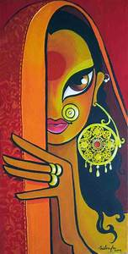 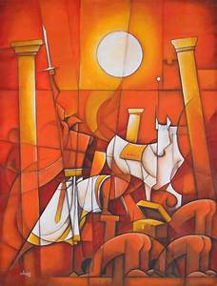 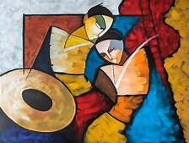

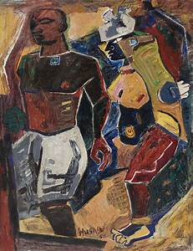 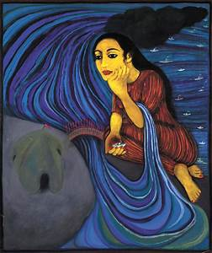 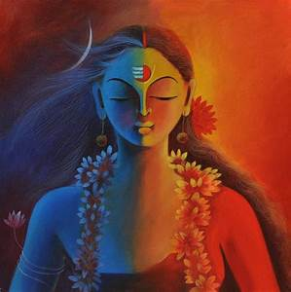

Image 4 (Source: https://images.search.yahoo.com/search/images) **Activity: Group Discussion**

Identify a suitable topic from the options given below for group discussion with your peers. Collect relevant pictures to cite as examples during the discussions. Form a group of maximum five members participating in the discussion. Post the discussion, submit a script of the discussion as a group assignment. (10 marks)

1. Emotions, mythological significance, and cultural representation modern paintings
2. Complex situations and feelings in modern paintings
3. Representation of deep emotions in modern paintings

**Session 5- SLO 1**

**Mughal paintings**

Mughal painting, Mughal also spelled Mogul, style of painting, confined mainly to book illustration and the production of individual miniatures that evolved in India during the reigns of the Mughal emperors (16th–18th century). Mughal painting was essentially a court art; it developed under the patronage of the ruling Mughal emperors and began to decline when the rulers lost interest. The subjects treated were generally secular, consisting of illustrations to historical works and Persian and Indian literature, portraits of the emperor and his court, studies of natural life, and genre scenes. (Source: https://www.britannica.com/art/Mughal-painting)

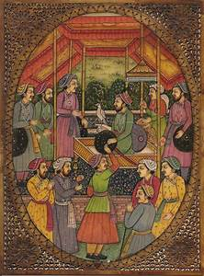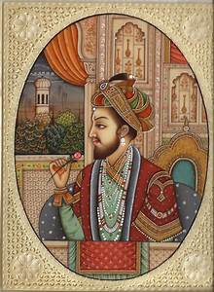 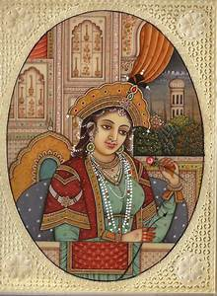 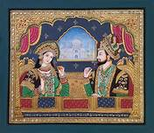 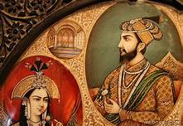 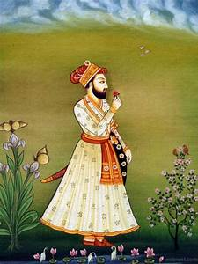

Image 5 (Source: https://images.search.yahoo.com/search/images)

**Individual Project**

‘Mughal used different themes to make their miniatures or paintings such as legendary stories, wildlife, royal life, hunting scenes, battlefield, Muslim mythology and more. And the best part of these paintings is that they have now become the main medium to describe the tales of the Mughal Empire’. Discuss how these paintings were not just paintings but an art of storytelling in about 500 words. Paste relevant pictures along with your write up. (10 marks)

**Session 5- SLO 2**

**Astonishing contemporary paintings by Indian artists**

Upon first looking at the work of a number of modern Indian artists, there seems little to differentiate their imagery from art made in other parts of the world. Yet their cultural heritage does affect their work, even if it is not apparent. In his ethereal abstract paintings, Natvar Bhavsar’s (born 1934) fields of color breathe and throb (1980.227). Although he moved to New York in the 1960s and was a contemporary of Abstract Expressionist painters, Indian culture continued to inform his work—Hinduism guided his use of colors, for instance. Nasreen Mohamedi (1937–1990) made minimalist ink drawings. The reverberating lines in her work recall Indian music, and she was influenced by the clean forms of Islamic architecture and design. The figurative work of Arpita Singh (born 1937) is made with pigment and very little oil to form cakes of impasto paint. This patchy quality references the folk art of quilts in India. And Krishna Reddy (born 1925) played with multiple printmaking techniques in Paris during the 1950s. He felt free in this environment in contrast to India, which had just experienced the light of freedom after centuries of foreign rule. (Source:https://www.metmuseum.org/toah/hd/mind/hd_mind.htm)

**Discussions**

Following are the names of the artists from India who are acknowledged as ‘India's 8 Most Expensive Contemporary Artists’. Discuss their contributions to the world of contemporary art.

Anish Kapoor, Atul Dodiya, Bharti Kher, Jitish Kallat, Raqib Shaw, Ravinder Reddy, Subodh Gupta

**Your Notes**

**Session 6- SLO 1 & 2**

**Fairs, festivals and local deities in the development of art forms**

**Myth, legends, snippets from epic, multitudinous gods born out of dream and fantasy in art forms**

Indian folk and tribal art have been thriving in the country since time immemorial and have been prominent in multiple vibrant forms which include paper-art, paintings, pottery crafts, metal crafts, toys, weaving and jewellery crafts. These varying art-forms are the rich reflections of the numerous customs, rituals and traditions which are followed by the inhabitants of the country - displaying unity in diversity. Folk and tribal arts of India have undergone transformation since a long time. They have evolved along with classical art. Tribal and folk art belong to the section of people who belong to different social groups and it has a native flavor. Tribal and folk art has the inclusion of fairs, festivals, local deities, fantasy in their representation. Indian art cannot do away with this section that has a regional and a mystic aura in it. Nomadic way of life is also an integral part of the folk arts, which was particularly practiced by nomads who were fond of traveling over the hills and valleys of India. (Source: https://www.indianetzone.com/10/indian_folk_tribal_art.htm)

**General Discussions with Quiz**

The following quiz has been borrowed from an online resource (https://www.funtrivia.com/playquiz/quiz3423922732548.html). Pay attention to each question and discuss the answers with your peers adding some information from you end.

1. The ancient art of India can be evidenced in the magnificent murals in the caves of Maharashtra. Besides murals, there are magnificent stone sculptures of Hindu deities, The Buddha and Jain Thirthankaras. There are three such caves which have been declared UNESCO World Heritage Sites. Two are the Ajanta and the Elephanta. What is the third one?

1. Aihole caves
2. Badami caves
3. Ellora caves
4. Caves at Aurangabad

2. The famous miniature painting style flourished under the rule of the Mughal ruler Akbar, but it declined under the rule of one Mughal emperor. Name this emperor.

1. Shah Jahan
2. Aurangzeb
3. Babur
4. Jehangir

3. In ancient India under the rule of the Kushanas, the Satvahanas and the Mauryas, two schools of sculpture developed. Both these schools were famous for sculptures of Buddha which they created in different styles. Can you name these two schools?

1. Gandhara, Nalanda
2. Nalanda, Sanchi
3. Sanchi, Sarnath
4. Sarnath, Gandhara

4. Born in the Travancore family of Kerala, he became one of the most famous artists of India. He developed his own style of painting, combining the realistic style of oil painting with the traditional Indian style of painting. He was famous for his paintings depicting scenes from the Mahabharata and Ramayana. Who was he?

1. Raja Ravi Verma
2. Narottam Narayan
3. Nandalal Bose
4. Cheenu Pillai

5. Does the tribal Indian art form of Madhubani come from the north Indian state of Uttar Pradesh?

Yes

No

6. He was one of the founders of the Bengal School of Painting. He was also the nephew of the Nobel Laureate, Rabindranath Tagore. Who was he?

1. Rabindradas Tagore
2. Nandalal Tagore
3. Abanindranath Tagore
4. Jamini Tagore

7. Born in Hungary, she became one of India's most celebrated artists. She is often called India's Frieda Kahlo. Who was she?

1. Amrita Shergill
2. Anjolie Ela Menon
3. Gogi Saroj Pal
4. B. Prabha

8. This form of painting comes from the South-Indian state of Tamil Nadu. It is famous for the use of high-quality gold foil along with semi-precious and precious stones. What is this form of painting?

1. Mysore Painting
2. Tanjore Painting
3. Rajput Painting
4. Warli Painting

9. Often known as the Picasso of India, he became one of the most successful artists in India. He unfortunately passed away in the month of June, 2011. He was also a writer and a film-maker. Who is he?

1. Maqbool Fida Hussain
2. Muhammad Feroz Hussain
3. Mirza Fakr-ud-din Hussain
4. Michael Fernandez Hussain

10. The Kalighat form of painting comes from Kolkata in the Indian state of Poschim Bengal (West Bengal).

True

False

Do you know that paintings have their origin from ancient past? They depict the life and customs followed by the people of those times. They also show how the kings and queens dressed or how the courtiers sat in the royal assembly. We can say that these paintings represent the culture of that time. Some of the literary sources also show that paintings whether religious or secular were considered an important form of artistic expression and were practised. Indian painting is the result of the synthesis of various traditions and its development is an ongoing process. This article deals with the Indian paintings which will help in various examination preparations. (Source: https://www.jagranjosh.com/general-knowledge/gk-questions-and-answers-on-indian-paintings-1504268949-1)

1. Which Buddhist text describes the existence of painted figures in many royal buildings?

A. Vinayapitaka

B. Sut Pitaka

C. Abhidhamma Pitaka

D. None of the above

2. Which of the following statements are correct regarding Paintings:

(a) Kamasutra written by Vatsayana mentions about 64 kinds of Paintings.

(b) The Vishnudharmottara purana has a section on painting called Chitrasutra.

(c) The play Mudrarakshasa mentions numerous Patas.

(d) Lepyacitras, lekhacitras are examples of various types of paintings of Gupta era.

Correct Options are:

A. (a) and (b) are correct

B. (b) and (d) are correct

C. (a) and (d) are correct

D. (a), (b) and (c) are correct

3. Flowers, leaves and plants were depicted first time in the paintings of which period?

A. Mughal Sultanat

B. Gupta Period

C. Delhi Sultanat

D. Maurya Period

4. Persian and Arabic influence in the Paintings were seen in which period of history?

A. Mughal Sultanat

B. Delhi Sultanat

C. Both A and B

D. Neither A nor B

Buddhist Mudras, Hand Gestures and Meaning

5. Miniature painting was developed in which part of India?

A. Northern India

B. North-West India

C. Eastern India

D. North-East India

6. In whose Emperor reign illumination and individual miniatures were replaced by wall painting, the most vital form of art?

A. Mohammad Bin Tughlaq

B. Alauddin Khilji

C. Akbar

D. Shah Jahan

7. The art of painting reached its climax during the period of which emperor of Medieval India?

A. Akbar

B. Shah Jahan

C. Jahangir

D. Aurangzeb

Mauryan Empire: Art and Architecture

8. Which of the following had played an important role in Bengal School of Art?

(a) Rabindranath Tagore

(b) Abanindranath Tagore

(c) E.B. Havell

(d) Ananda Kehtish

Correct Options are:

A. Both (a) and (b)

B. Both (b) and (c)

C. Both (c) and (d)

D. All of the above

9. The Progressive Artists Group in Bombay in 1948 was developed under ...........

A. K.C.S Paniker

B. S .H. Raza

C. Francis Newton Souza

D. S.K. Bakre

10. Which of the following belong to Madras School of Art?

A. Debi Prasad Roy Chowdhury

B. K.C.S Paniker

C. Both A and B

D. Neither A nor B

**Notes**

**MODULE 2**

**Session 1- SLO 1**

**Indus Valley civilization paintings on pottery**

In Indus Valley Civilization, pottery was an important industry and the significance of the pottery can be noted from the fact that harappan pictographical scripts were mainly found on potteries. Indus Valley Civilization Pottery, remained plain most of the times and it further enabled us to understand the gradual evolution of various design motifs as employed in different shapes, and styles. Indus Valley Civilization consists chiefly of wheel made wares (although potters' wheels, being made of wood, have not survived) both plain and painted while the plain pottery (usually of red clay with or without a fine red slip) is more common than the painted ware (of red and black colours).

The painted decorations consist of horizontal lines of varied thickness, scales, chequers, leaf patterns, lattice work, palm and pipal trees. Additionally, Birds, fishes and animals are also shown. Among the notable shapes found in the Harappan pottery are pedestal, dishes, goblets, cylindrical vessels perforated all over and various kinds of bowls. The uniformity in the forms and paintings on the pottery is difficult to explain and normally the explanation of this uniformity is the fact that the local potters made the pottery. However, it is still unclear how such a large area exhibited a uniform pottery tradition. Although the Indus pottery is mostly represented by the plain bases but few ring bases discovered were on handmade pottery, which was supposed to be baked at home. Pottery made on potter's wheel and burnt in kilns, has shown marks of stamp which might indicate that a few varieties of vessels were traded also. (Source: https://neostencil.com/upsc-art-culture-indus-valley-civilization-pottery)

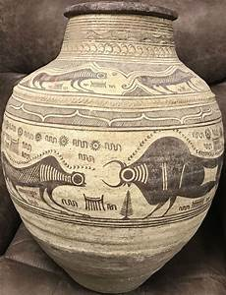 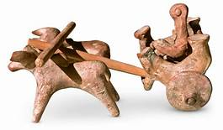 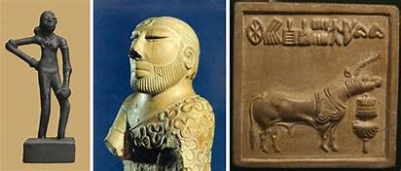

Image 6(Source: https://images.search.yahoo.com/search/images )

**Assignment**

Write brief notes on the following artworks from Indus Valley civilization. Paste relevant images along with your writing. (10 marks)

1. Stone Statues: Bearded Man (Priest Man, Priest-King), Indus Valley Priest, Male Torso
2. Bronze Casting: Human as well as animal figures - buffalo with its uplifted head, goat, dog and bird, bull, Dancing Girl
3. Terracotta: bearded males, terracotta mask of a horned deity, Toy carts with wheels, whistles, rattles, bird and animals, gamesmen, and discs, figures of Mother Goddess.
4. Seals: beautiful figures of animals such as unicorn bull, rhinoceros, tiger, elephant, bison, goat, buffalo, etc., Pashupati Mahadeva
5. Pottery: Painted Earthen Jar
6. Beads, Ornaments and Cosmetics

**Notes:**

**Session 1 & 2- All SLOs**

**Cave paintings from different parts of India**

India is known for its diversified art and culture. As per research and records, the oldest existing proofs of art in India can be traced back to the Stone Age. This tells us that the aesthetic value of art is such that it found a way to flourish even at the time when man was not civilized. Dating back to 30,000 years ago, paintings have for long been associated with Indian civilization. Cave paintings in India have been discovered in Karnataka, Madhya Pradesh, Maharashtra, and Uttar Pradesh among many other places. India’s rich history of paintings has called for recognition from all over the globe. (Source: https://yehaindia.com/cave-paintings-in-india)

**Group Activity**

Read and collect information for the following Cave paintings from different parts of India. Gather relevant images. Paste the images with the description. (20 marks)

Here are some of the most famous cave painting found in India:

**1. Bhimbetka Cave Paintings - Location**: Near Bhopal in Madhya Pradesh

**2. Sittanavasal Paintings - Location:** Puddukotai district of Tamil Nadu.

**3. Ajanta - Location:**100 Kms from Aurangabad in Maharashtra

**4. Ellora - Location**: 18 miles to Aurangabad in Maharashtra

**5. Lenyadri Cave Paintings - Location:** Junnar in Pune district in Maharashtra

**6. Badami Caves - Location:**Badami, a small town in Bagalkot District in Northern Karnataka

**7. Adamgarh Hills - Location** : Hoshangabad town in Madhya Pradesh

**8. Jogimara Cave Paintings - Location:** Chattisgarh

**9. Saspol Caves - Location:**Saspol village in Leh district

**10. Elephanta Caves - Location:**Ellora Island in Maharashtra

**Notes:**

**Session 3- SLO 1 & 2**

**Thanjavur, Madhubani paintings**

Tanjore paintings or Thanjavur paintings have been popular from 16th century during the Marathas invasion to Southern india. If you have visited the temples in South India, most of them will have pictures of gods and goddess which are Tanjore paintings. It’s believed tanjore paintings started from Thanjavur a small town in Tamil Nadu and hence the name. Thanjavur district is quite popular for it’s toys and crafts. The famous Thanjavur thalai aati bommai was created here. These are simple standing wooden toys, but these are special head shaking toys. (Source: https://webneel.com/tanjore-paintings-thanjavur)

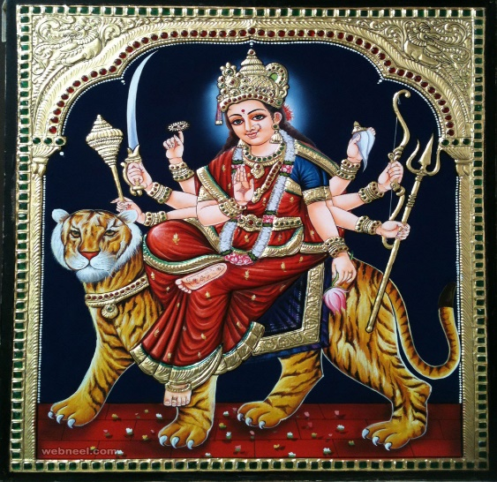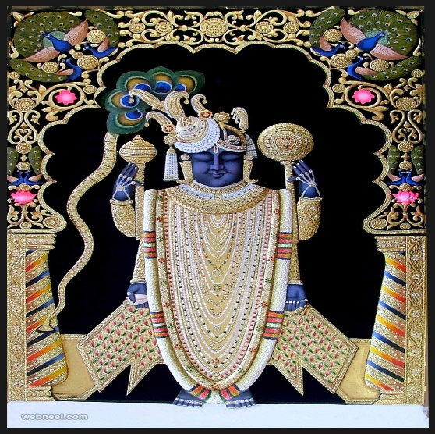 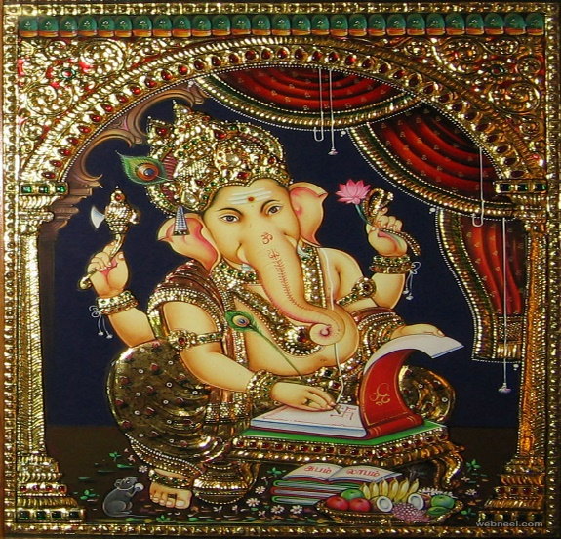 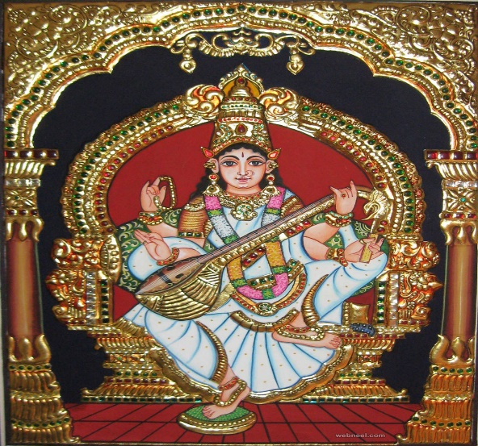

Image 7 (Source: https://webneel.com/tanjore-paintings-thanjavur)

Madhubani Paintings revolve around a historical tale. It goes back to the era of Ramayana when King Janak, Sita’s father asks few painters to create Madhubani paintings for his daughter’s wedding. The colors used are often extracted from natural sources. Madhubani has inherited every bit of nature. Right from parrots, pigeons, quails, colorful and melodious nightingales, the place has it all. In addition, thatched roofs of mud houses foiled with squash vines, tall palm trees, bodi and peepal trees in sprinkled sunlight are breathtaking.There are other religious themes that revolve around Madhubani paintings. Some of them include Hindu deities like Krishna, Shiva, Saraswati, Rama, sun, moon etc. Most of the Madhubani paintings signify simplicity with intricate brushwork. Geometric patterns are quite evident in these paintings. The artists fill up the empty spaces with motifs after completing a painting. A double line is usually drawn as the border. In fact, the artists used turmeric, charcoal fire, milk & lime juice, indigo and flowers for Madhubani paintings. However, most of the modern Madhubani painters use brush and acrylic paints.

**Assignment**

Identify a small, simple, yet beautiful Madhubani painting from web resources. Emulate the painting using sketch colours, duly acknowledging the source. Alternately, create your own Madhubani painting. Paste the image in the space given below. (10 marks)

**Session 4- SLO 1 & 2**

**Kalamkari paintings**

Kalamkari Paintings are the famous hand painting style and the pictures in Kalamkari style passionate the art lovers. The pictures drawn on cotton or silk fabric with tamarind pen or natural dyes. The word ‘Kalamkari’ is a Persian word, here Kalam means pen and Kari mean craftsmanship. The painting style and the process of painting the pictures very difficult. To bring the full form of the painting the artist follow 23 tedious steps of dyeing, bleaching, block printing, starching and more processes should follow. The pictures on the clothes mostly adopted from the themes of Hindu epics Mahabharata and Ramayana and also the flowers, peacocks and other divine characters also painted on cloth in Kalamkari process. (Source: https://indiathedestiny.com/india-art-culture/art/kalamkari-paintings/)

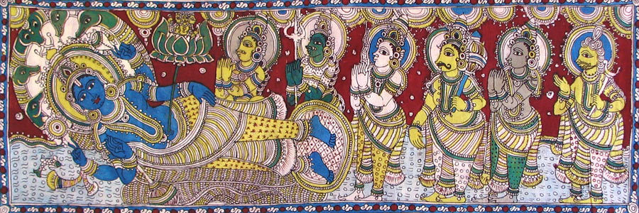

Image 8 (Source: https://indiathedestiny.com/india-art-culture/art/kalamkari-paintings/)

**Quiz**

The following quiz borrowed from a web source (http://godivinity.org/quiz-time-indian-art-kalamkari/), would add to your general knowledge about Kalamkari art. Discuss the questions with your peers and look for answers.

1. What fabric is Kalamkari art done on?
   1. Polyster B. Cotton C. Canvas
2. Another name for Kalamkari art is “pattachitra”, which means _______________.
   1. Beautiful painting B. Colorful Art C. Cloth picture
3. Where were Kalamkari art pieces traditionally displayed?
   1. Markets B. Temples C. Homes
4. Storytellers often used Kalamkari art in performances of ______.
   1. Religious stories B. Popular myths C. Folk tales
5. What are the sources for the colors that are generally used in Kalamkari art?
   1. Plant B. Oil paint C. Ink
6. When creating patterns, certain areas of cloth need to be masked to protect it from the ink. What material is used?
   1. Painter’s tape B. Glue C. Wax
7. There are ______ distinctive styles of Kalamkari art.
   1. Two B. Five C. Seven
8. Kalamkari art was used in ancient times as ____________ .
   1. Chariot banners, wall hangings in temples, and scrolls. B. Wall hangings in homes C. Sarees
9. Name the different styles of Kalamkari paintings.
   1. Katchni, Barni, Tantrik, Godna and Kohbar B. Srikalahasthi and Machilipatnam
   2. Pattachitra, Warli, Bharni, Katchni and Tantrik
10. What does “Kalamkari” mean?

A. Kalam (pen) + kari (work) B. Kalam (time) + kari (work) C Kalam (color) + kari (painting)

1. Where was Kalamkari most popular in the Middle Ages?
   1. Chennai B. Hyderabad C. Jaipur
2. An animal’s milk is used in fixing the dyes to the fabric. Which animal’s milk is used in fixing the dyes to the fabric?
   1. Cow B. Goat C. Buffalo

**Notes:**

**Session 5- SLO 1 & 2**

**Pattachitra paintings**

The paintings on the caves of Khandagiri and Udayagiri and Sitabhinji murals of the Sixth century A.D., the earliest indigenous paintings from Orissa are the Pattachitra done by the Chitrakars (the painters are called Chitrakars). They do not belong to any particular place but the district of Puri has the highest concentration of Chitrakars. The word Patta is a Sanskrit word meaning canvas and Chitra meaning picture. This art form is defined by its rich use of colour, its creative motifs and designs, and its portrayal of pure and simple themes. Hindu mythological themes revolve around this art form and mostly deal with stories from Mahabharata, Ramayana and legends concerning Radha and Krishna, Lord Jagannath and other popular legends. But the most popular is the depiction of Sri.Jagannath, Balabhadra and Subhadra, the Divine triad or Sri. Jagannath Patti. The chitrakars do not strive for realism but a definite expressive of feeling and emotion is strongly visualized in their work with neat patterns and designs that calls for a closer observation for appreciation. Though it can be mistaken for an art form with colour symbolism due to its rich use of colours, it is not so. In fact, it seems to be its visual effect and appeal that touches the human emotions directly, which rules the painting. Borders are an integral part of the painting and this is drawn first on the painting on all the four sides of the patta consisting of two or three lines according to the size of the painting. The outlines of the figures are drawn first with very thin lines in white. The body colours are then added followed by colouring the attires. The figures are then adored with ornaments and coloured. Outlines of other motifs are then thickened with a thick brush with black colour. Then small and fine decorative motifs are painted in white. It is interesting to note that the chitrakar begins his painting with the colour white and ends with it too. The eyeballs are the last to be inserted on the painting. Sometimes a painting is done only in black and white. With perfect mastery over fine line drawing, the Chitrakars make the paintings come alive with their skill and workmanship. (Source: <https://www.nriol.com/indian-paintings/pattachitra-paintings.asp>)

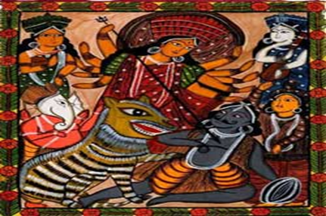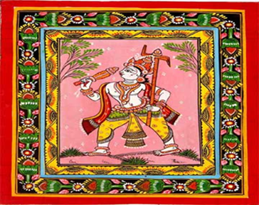

Image 9 (Source: https://www.nriol.com/indian-paintings/pattachitra-paintings.asp)

**Assignment**

Watch “Easy Pattachitra painting tutorial/ RADHA KRISHNA pattachitra painting for beginners” on https://www.youtube.com/watch?v=8VUCceI29Lc. Attempt a painting taking ideas from it. (10 marks)

**Session 6- SLO 1 & 2**

**Mughal paintings**

**Quiz**

Discuss the following questions from the web source (https://www.currentgk.com/)

1. Which statement is true about the Mughal paintings?
   1. Battle Scene (B) Animal birds and natural scene (C) Courtier depicting (D) All of the above
2. The foundation of the Mughal painting was laid by
   1. Akbar (B) Humayun (C) Jahangir (D) Shah Jahan
3. Who did illustrate “Dastan-e-Amir Hamza”?
   1. Abdus Samad (B) Mansur (C) Mir Sayyid Ali (D) Abul Hasan
4. During whose reign did the “Mughal Painting” flourish?
   1. Aurangzeb (B) Akbar (C) Jahangir (D) Shah Jahan
5. Jahangir mainly patronized which of the following arts?
   1. Painting (B) Architecture (C) Sculpture (D) Music
6. ‘Kishan Garh’ School is famous for
   1. Temple Art (B) Painting (C) MartialArts (D) Sculpture
7. Which one of the following musical instruments was mastered by Aurangzeb?
   1. Sitar (B) Pakhawaj (C) Veena (D) None of the above
8. The Raga which is sung early in the morning is
   1. Todi (B) Darbari (C) Bhopali (D) Bhimpalasi
9. Where is Tansen’s tomb located?
   1. Agra (B) Gwalior (C) Jhansi (D) Jaipur
10. The original name of Tansen was
    1. Makarchand Pandey (B) Ramtanu Pandey (C) Lala Kalawant (D) Baz Bahadur
11. Which Mughal ruler of the following had learnt Hindu Music from Lala Kalavant?
    1. Humayun (B) Jahangir (C) Akbar (D) Shahjahan
12. Who among the following wrote historical records in the Mughal period?
    1. Gulbadan Begum (B) Nur Jahan Begum (C) JahanaraBegum (D) Zebunnisa Begum

**Notes:**

**MODULE 3**

**Session 1- SLO 1 & 2**

**Terra Cota**

Terracotta, taken from Latin terra cotta or baked earth, is the art of creating glazed or unglazed porous earthenware, figurines, and other decorative materials from clay which is dried and fired in temperatures of around 1000°C giving it a distinctly orange, red, brown, yellow, or grey color. It is then covered in sand to allow it to cool down. This color depends not only on the type of clay found in the beds of the water bodies in the area where the artist is based but also on the firing process. For example, if the smoke from firing is allowed to get out through the vents in the kiln, a red or orange color is obtained. On the other hand, if the vents are sealed, it gives the items a black color. Decorative pieces are either left with their original color or painted in multiple hues to make them more attractive. Terracotta items, when not cracked, give a ring when struck lightly with fingers. (Source: dollsofindia.com/library/terracotta-art/)

**Essay writing**

Write a paragraph in about 100 words on ‘why use terracotta today?’ in the space provided below. (5 marks)

**Session 2- SLO 1 & 2**

**Rock cut sculpture, Sculptures in religious buildings**

Indian rock cut sculpture involves a dexterous sculptural art which is derived after cutting out the solid rocks to produce mythological scenes, fanaticism and eroticism mainly found in the states of Bihar, Orissa, Maharashtra, Madhya Pradesh and some states of south India. The rock cut art is more similar to sculpture than architecture as cutting out solid rocks produced structures. Some of the finest rocks cut structures are found in Bihar and Maharashtra. 'Chaityas' and 'viharas' are rock cut structures made for Buddhist and Jain monks as their residence and worshipping zones. (Source: https://www.indianetzone.com/10/indian_rock_cut_art.htm)

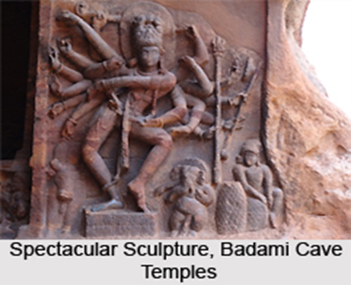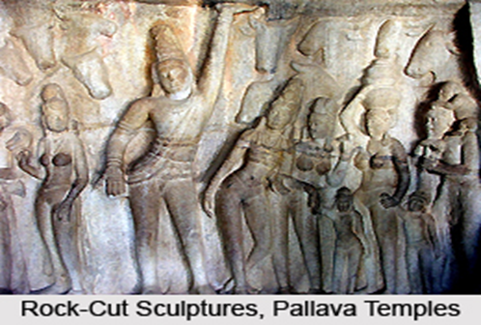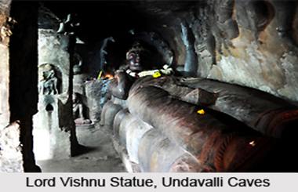

Image 10 (Source: https://www.indianetzone.com/10/indian_rock_cut_art.htm )

**Assignment**

Write short notes on the following topics: (20 marks)

1. Earliest Rock-Cut Cave Sculptures.
2. Rock-Cut Sculptures of Cave Temples:
3. Rock-Cut Sculptures of Monolithic Temples
4. Rock-Cut Sculptures of Free Standing Temples
5. Rock-Cut Sculptures of Rock Cut Monuments

**Notes:**

**Session 3- SLO 1**

**Buddhism, Hinduism, and Jainism in sculptures**

Read the following excerpts about Buddhism, Hinduism, and Jainism in sculptures from larger texts gathered from web resources. Discuss with your peers and add more information to them along with relevant images.

Although these three religions have many similarities, there are several differences as well. For example, Buddhism, Jainism, and Hinduism all have a philosophy developed system. However, Hinduism is based on the Brahmana system and Buddhism and Jainism are based on the Samana system. First, the Brahmana system includes gods with a cyclic process. In other words, the gods are the Creator (Brahman), the Preserver (Vishnu), and the Destroyer (Shiva), just like the God in Christianity, where God is powerful and makes all the judgements. (Source: http://jainism-project.weebly.com/jainism-vs-buddhism-vs-hinduism.html)

Buddhist art includes sculptures, paintings and other art forms that represent the stories and concepts of Buddhism. The earliest Buddhist art, which originated in India, was mostly symbolic and avoided figurative depictions of the Buddha. Later, as Buddhism developed and spread to a variety of cultures, its religous art came to represent the Buddha, boddhisatvas, and gods in rich figurative imagery. Ritual art, such as the intricate mandalas used in meditation, is also an important aspect of Buddhist art. (Source: http://www.religionfacts.com/buddhism/art )

Hindu art reflects this plurality of beliefs, and Hindu temples, in which architecture and sculpture are inextricably connected, are usually devoted to different deities. Deities commonly worshiped include Shiva the Destroyer; Vishnu in his incarnations as Rama and Krishna; Ganesha, the elephant god of prosperity; and different forms of the goddess Shakti (literally meaning “power”), the primordial feminine creative principle. These deities are often portrayed with multiple limbs and heads, demonstrating the extent of the god’s power and ability. Hindu art is also characterized by a number of recurring holy symbols, including the om, an invocation of the divine consciousness of God; the swastika, a symbol of auspiciousness; and the lotus flower, a symbol of purity, beauty, fertility, and transcendence. (Source : https://courses.lumenlearning.com/boundless-arthistory/chapter/hindu-art)

Modern and medieval Jains built many temples, especially in western India. The earliest Jain monuments were temples based on the Brahmanical Hindu temple plan and monasteries for Jain monks. For the most part, artists in ancient India belonged to non-denominational guilds who were prepared to lend their services to any patron , whether Hindu, Buddhist, or Jain. Many of the styles they used were a function of the time and place rather than the particular religion. Therefore, Jain art from this period is stylistically similar to Hindu or Buddhist art, although its themes and iconography are specifically Jain. With some minor variations, the western style of Indian art endured throughout the 16th century and into the 17th century. The rise in Islam contributed to the decline of Jain art but did not result in its total elimination. (Source: https://courses.lumenlearning.com/boundless-arthistory/chapter/jain-art/)

**Session 4- SLO 1**

**Bronze sculptures in India**

* We know that Indian sculptures were masters in terracotta sculpturing and carving in stones. They were masters in the bronze medium too.
* Bronze is Copper + Tin.
* The ‘Cire-Perdu’ or ‘Lost Wax’ technique for casting was learnt as long ago as the Indus Valley Civilization.
* The ‘Dancing Girl’ in tribhanga posture found from Mohenjo-Daro is the earliest bronze sculpture datable to 2500 BCE.
* Sculptors discovered the process of making alloys of metals by mixing copper, zinc and tin which called Bronze.
* Bronze sculptures and statuettes of Buddhist, Hindu and Jain icons have been discovered from many regions of India dating from the 2nd century AD until the 16th century AD.
* Most of these were required for ritual worship and are characterized by exquisite beauty and aesthetic appeal.
* The metal casting process was also used for making articles for various purposes of daily use, such as utensils for cooking, eating, drinking, etc.
* The present day tribal communities also utilizes the ‘lost wax’ process for their artistic expression.

**Quiz**

Discuss the following questions with your peers collected from web source (https://study.com/academy/practice/quiz-worksheet-indian-bronze-age.html)

1. The first major Bronze-Age civilizations in the Indian subcontinent were based around what natural feature?
   1. The Ganges River b. The Indus River c. The Himalayan Mountains d. The Thar Desert
2. Apart from bronze, Bronze-Age civilizations are largely defined by the first major appearance of what?

a. Iron b. Farming c. Urbanization d. Trade

1. Harappan civilizations displayed most of the expected traits of a Bronze-Age society, except what?

a. Writing b. Well-organized cities c. The development of bronze d. A centralized government

**Session 4- SLO 2**

**Cultural stonework in India in the form of primitive cupule art**

Cultural stonework in India - in the form of primitive cupule art - dates back to the era of prehistoric art of the Lower Paleolithic, around 700,000 BCE - see Bhimbetka Petroglyphs (Auditorium Cave and Daraki-Chattan Rock Shelter, Madhya Pradesh). By the time of the Bronze Age, sculpture was already the predominant form of artistic expression throughout the Indian subcontinent, even though mural painting was also popular. Sculpture was used mainly as a form of religious art to illustrate the principles of Hinduism, Buddhism, or Jainism. The female nude in particular was used to depict the numerous attributes of the gods, for which it was often endowed with multiples heads and arms. There was certainly no tradition of individuality in Indian sculpture: instead, figures were conceived of as symbols of eternal values. In simple terms, one can say that - historically - Indian sculptors have focused not on three-dimensional volume and fullness, but on linear character - that is to say, the figure is designed on the basis of its outline, and is typically graceful and slender. The origin of plastic art in India dates back to the northwestern Indus valley civilization, which was noted primarily for its terracotta sculpture - mainly small figurines - but also for the pioneering bronze sculpture of the Harappan Culture. Other important milestones in the history of sculpture include: the Buddhist Pillars of Ashoka of the Mauryan period, with their wonderful carved capitals (3rd century BCE); the figurative Greco-Buddhist sculpture of the Gandhara and Mathura schools, and the Hindu art of the Gupta period (1st-6th century CE). Over the next five centuries, a wide range of sculptural idioms flourished in many different areas of present-day Pakistan, India and Bangladesh, but by the time of the Khajuraho Temples in Madhya Pradesh, which were erected in the 10th/11th century by the Chandela dynasty, and which were renowned for the erotic content of their stone sculpture, Indian sculpture had reached the end of its most creative stage. From then on, sculpture was designed mostly as a form of architectural decoration, with huge quantities of small, mediocre figures being manufactured for this purpose. It has continued in this way, with little significant change, up to the present. For sculpture from across Asia, see: Asian Art (from 38,000 BCE). (Source: https://brainly.in/question/3210131#readmore)

**Peer Discussions**

Discuss the following questions, alternately, find answers for them:

1. When Were Cupules Made?
2. What Are the Main Characteristics of Cupules?
3. Where Do Cupules Occur?
4. What Are the Oldest Known Cupules?
5. What is the Purpose of Cupules? Why Were They Made?

**Notes:**

**Session 5- SLO 1 & 2**

**The Buddhist Pillars of Ashoka of the Mauryan period**

Read the following excerpts and discuss the contents with your peers.

One of Ashoka’s first artistic programs was to erect the pillars that are now scattered throughout what was the Mauryan empire. The pillars vary from 40 to 50 feet in height. They are cut from two different types of stone—one for the shaft and another for the capital. The shaft was almost always cut from a single piece of stone. Laborers cut and dragged the stone from quarries in Mathura and Chunar, located in the northern part of India within Ashoka’s empire. The pillars weigh about 50 tons each. Only 19 of the original pillars survive and many are in fragments. The first pillar was discovered in the 16th century. The physical appearance of the pillars underscores the Buddhist doctrine. Most of the pillars were topped by sculptures of animals. Each pillar is also topped by an inverted lotus flower, which is the most pervasive symbol of Buddhism. (Text and image 10 Source: https://www.themysteriousindia.net/the-pillars-of-ashoka/)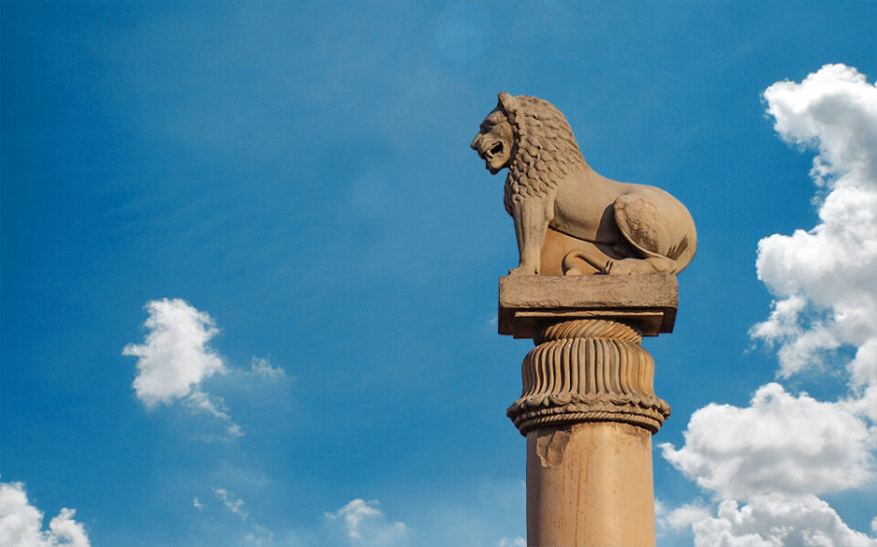Gandhara art, style of Buddhist visual art that developed in what is now northwestern Pakistan and eastern Afghanistan between the 1st century BCE and the 7th century CE. The style, of Greco-Roman origin, seems to have flourished largely during the Kushan dynasty and was contemporaneous with an important but dissimilar school of Kushan art at Mathura (Uttar Pradesh, India). 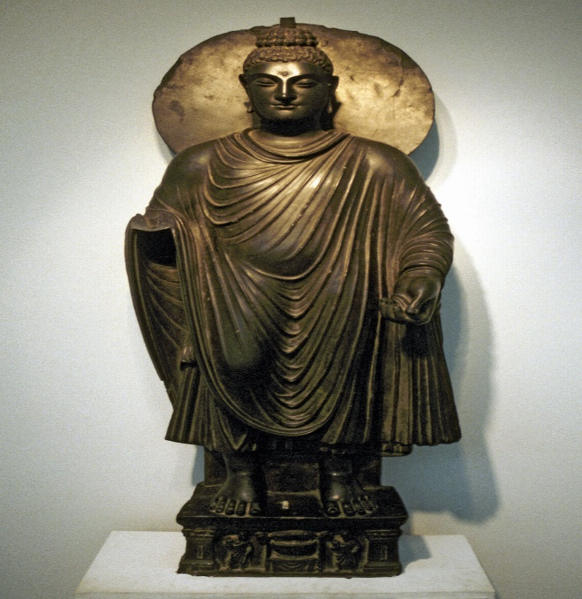(Text and Image 11 source: https://www.britannica.com/art/Gandhara-art)

**Indian art and architecture: The Gupta Period**

Buddhist art flourished during this period, which has often been described as a golden age. A famous rock-cut monastery at Ajanta consists of several chaitya halls and numerous residential viharas. Both facades and interiors contain elegant relief sculpture, while interiors are covered with painted murals that feature superb figures drawn with a gracefully sinuous line. As in all periods, there is little difference in the images of the major Indian religions, Buddhist, Hindu, and Jain. Large stone figures, stone and terra-cotta reliefs, and large and small bronzes are made in the refined Gupta style; the level of production is uniformly high. After the 7th cent., although the rulers of the Pala and Sena dynasties (730–1197) were Hindu, significant Buddhist art was created. Images in bronze and in hard black stone from Nalanda and elsewhere reveal a development of the Gupta manner, with extensive attention to ornamental details. (Source: https://www.infoplease.com/encyclopedia/arts/visual/asian-middle-eastern/indian-art-and-architecture/the-gupta-period)

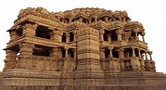 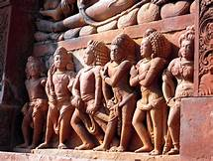 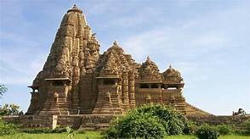

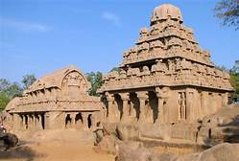 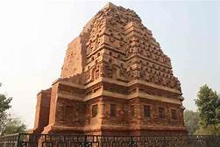 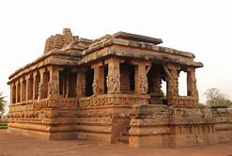

Image 12 (Image: https://images.search.yahoo.com/search/images)

**Session 6- SLO 1**

Madhya Pradesh is a central state in India. It is also known as the heart of India. Madhya Pradesh is the land of various cultures and traditions. It is considered to be among the most beautiful and varied state of India , this place has been grandeur era of Malava, Dasani, Maurya, Chandra dynasties. It is the home to people of all origin and ethnicities. During a trip to Madhya Pradesh, one must visit the famous temples that are considered to be pious and sacred places of devotion by the devotees. There are many temples that are dedicated to Lord Shiva, Vishnu their avatars and Goddess Lakshmi. The list of must-visit temples is as follows. Collect information for each: (10 marks)

Kandariya Mahadeva Temple - Lakshmana Temple, Khajuraho - Chaturbhuj Temple - Javari Temple, Khajuraho - Vamana Temple, Khajuraho - Varaha Temple Khajuraho - Duladeo Temple Khajuraho - Devi Jagadambika Temple - Matangeshwar Mandir Khajuraho - Lakshmi Temple Khajuraho

**MODULE 4**

**Session 1- SLO 1 & 2**

**Kolam - the traditional floor drawing of South India**

Kolam is a drawing generally drawn at the entrance of a house or any other building. This is a very old practice in South India. Dried rice flour or other types of white powders are used for drawing kolams. Although there are numerous traditional kolams patterns and lot more can be created depending on the creativity of the person who draws it, it is not drawn like a picture. Patterns are created based on certain systems. Drawing Kolam is practiced by women. Generally women get up early in the morning and clean the area just outside the entranes of their houses, sprinkle the area with water and draw the kolam by dropping the loose dried flour in a controlled way through their forefinger and the thumb. Mostly the kolam patterns are created based on dots arranged in different types of grid patterns. However, many non-dot based kolam patterns also are available. (Source: https://kalaskolangal.blogspot.com/2011/04/kolam-traditional-floor-drawing-of.html) **Assignment**

Emulate the following Kolam designs (any two) and share images of your works. (10 marks)

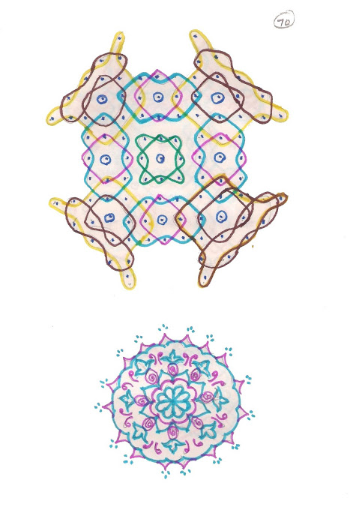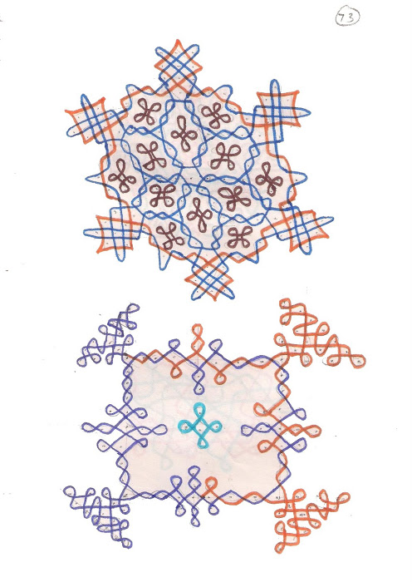 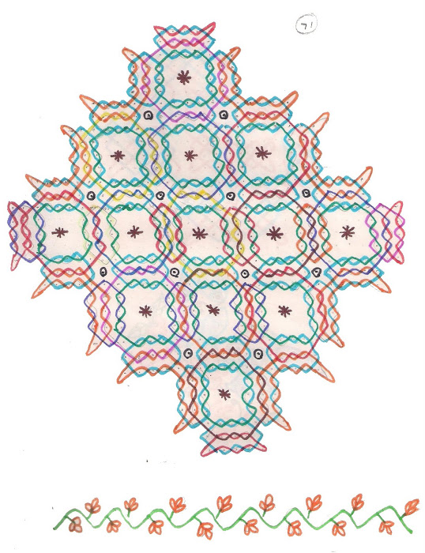 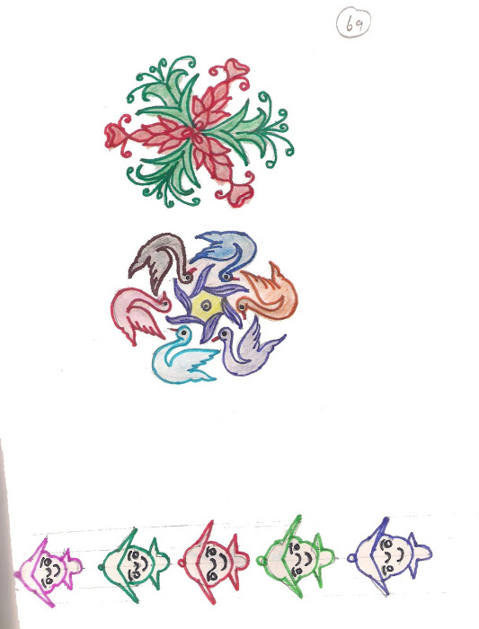

Image 13 (Source: https://kalaskolangal.blogspot.com/2011/04/kolam-traditional-floor-drawing-of.html)

**Session 2- SLO 1**

**Rangoli – Occasions and motifs**

It is considered auspicious to draw rangoli in Hindu Dharma during special occasions and religious ceremonies. Rangolis are believed to have spiritual perspective and benefits. It is said that with the change of color, design and form, the vibration of a rangoli changes. There have been several internet resources and booklets on rangoli designs that attract and transmit energies of deity principles. The devotees are said to have experienced several feelings ranging from spiritual energy to divine energy, divine consciousness and serenity. (Image: https://www.arenaflowers.co.in/blog/rangoli-and-its-spiritual-significance/)

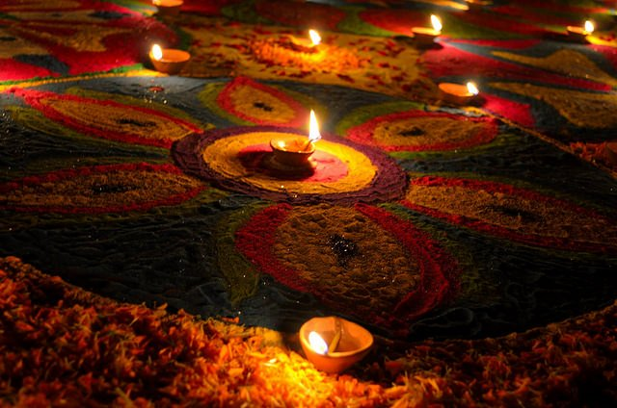 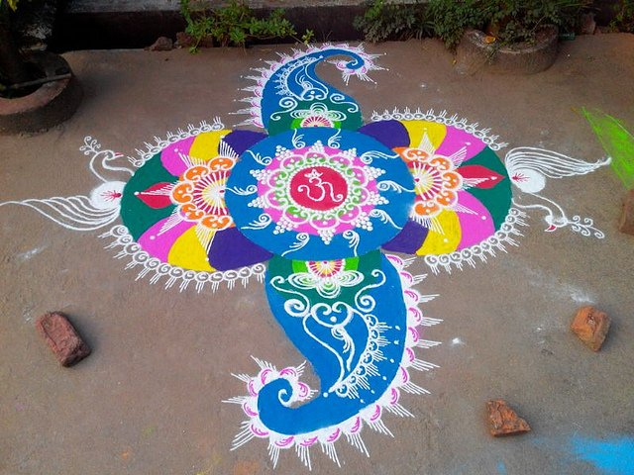

Image 14 (Source: https://www.arenaflowers.co.in/blog/rangoli-and-its-spiritual-significance/)

**Assignment**

Write a note on the importance of Symmetry in Rangoli in the space provided below. (5 marks)

**Session 3- SLO 1**

**Kalamezhuthu in Kerala - Religious significance**

Kalam in Malayalam means picture and ezhuthu denotes the act of drawing. Kalamezhuthu is observed mostly in Bhagavathy / Bhadrakali temples of Kerala. The deities usually depicted are Goddess Bhadrakali, Lord Ayyappa, Naga Devata (serpent goddess) etc. These drawings, essentially non-Aryan in nature, are impregnated with ferocity that inspires awe and devotion among the devotees. There are certain traditional norms followed by the artistes in this type of drawing, which varies according to the traditions followed, community involved and the deity worshipped or drawn. The ritual of Kalamezhuthu develops through three stages - Kalamezhuthu, drawing of the picture, Kalam Pattu, which involves the rendering of the myth related to the deity to the accompaniment of some traditional instruments and Kalam Thullal, the final stage in which the myth is performed in a stylised form following which the Kalam is erased. This art form is multi-dimensional in that it bears religious, aesthetic and social aspects. Kalamezhuthu is a combination of two-dimensional and three-dimensional designs drawn with the colours black, white, green, yellow and red. What is unique is that the colours used are natural products. Burnt husk of paddy is used for black colour, powdered turmeric for yellow and powdered leaves and mylanchi (henna) for green. These hues are further mixed to obtain more combinations.The outline is drawn with powdered rice, which is also used to get white colour. The scale varies from five meters to three meters. The deity is drawn in bright colors and in a dark background. When the bell metal lamps placed on the four corners of the drawing are lighted what ensues is an enticing piece of art. These awe-inspiring depictions will lead one to the roots of the aesthetic traditions of Kerala.

**Assignment**

Paste two images of Kalamezhuthu in the space given below: (5 marks)

**Session 3- SLO 2**

Mandana paintings are wall and floor paintings of Rajasthan and Madhya Pradesh. Mandana are drawn to protect home and hearth, welcome gods into the house and as a mark of celebrations on festive occasions. Village women in the Sawai Madhopur area of Rajasthan possess skill for developing designs of perfect symmetry and accuracy. The art is typically passed on from mother to daughter and uses white khariya or chalk solution and geru or red ochre. They use twigs to draw on the floors and walls of their houses, which are first plastered with clay mixed with cow dung. More tools employed are a piece of cotton, a tuft of hair, or a rudimentary brush made out of a date stick. The design may show Ganesha, peacocks, women at work, tigers, floral motifs, etc.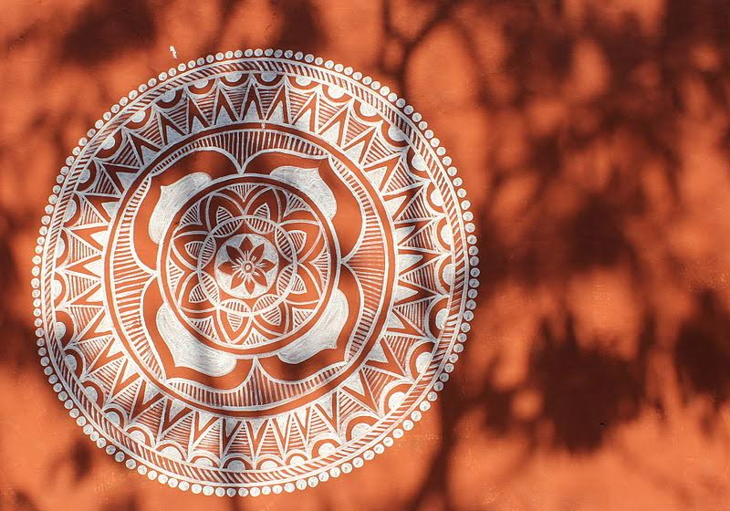In the Meena villages of Rajasthan women paint not just the walls and floors of their own homes to mark festivals and the passing seasons, but public and communal areas as well, working together and never leaving individual signatures. Image result for mandana designs rajasthaniFamed for warding off evil and acting as a good luck charm, the tribal paintings are derived from the word ‘Mandan’ referring to decoration and beautification and comprises simple geometric forms like triangles, squares and circles to decorate houses.

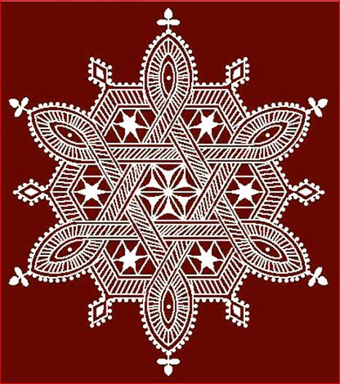 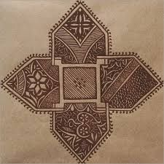

Though Mandana art has seen a drastic drop in visibility, and has less of takers among villagers due to rise in number of concrete houses, the art still holds the rustic charm, and its paintings adorn walls of patrons. According to experts in the Mandana art form, the traditionally drawn designs bear architectural and scientific significance. Text and Images 15 (Source: http://one2all.co.in/mandana/)

**Assignment**

Draw a simple mandana design in the space provided below. (5 marks)

**Session 4- SLO 1 & 2**

**Bengal’s floor art-Alpona**

It is mainly during festivals such as Durga Puja that we get to witness beautifully designed and decorated floor art that adds to the mood of the celebrations. In Bengal and Assam, this floor art is called alpona, aripana in Bihar, pakhamba in Manipur, jinnuti in Orissa, mandana in Rajasthan, rangoli in Maharashtra, likhnu in Himachal Pradesh, apna in Almora and Nainital region, kolam in Tamil Nadu, and muggulu in Andhra Pradesh – together, they form a part of a rich folk art genre. Practised by drawing geometrical or free-hand motifs on the floor, it’s a fairly laborious art form. (Source: https://indianexpress.com/article/lifestyle/art-and-culture/durga-puja-alpona-food-ants-an-antiseptic-5407403/)

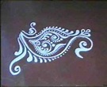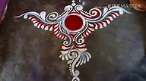 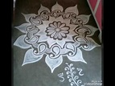 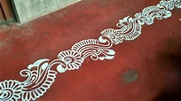 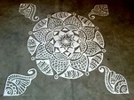 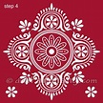

Image 16 (Source: https://search.yahoo.com/search)

Assignment

Watch the Alpona tutorial on https://www.youtube.com/watch?v=uW8F8nqzT30 and create your own design inspired from the artist in the space provided below. (5 marks)

Discuss what floor art is done during festivals in your homeland. (5 marks)

**Session 5- SLO 2**

**Pookalam: The Onam Floral Rangoli**

In kerala ‘Pookalam’ or the flower rangoli marks the festival of Onam. ‘Poo’ means ‘flower’ and ‘Kalam’ means artwork. Floral Rangoli or the ‘Onam Kolam’ is a very important part of the Onam celebrations. On the very propitious celebration of Onam, Malayalee families all over the world decorate the entrance of their home with flowers and colors. Pookalam is a colorful arrangement of colors and flowers on the floor. The floral rangoli or the ‘Pookalam’ is an integral part of the celebration of Onam. According to the legends mighty King Mahabali who once ruled the region, visit the land during these ten days of Onam festival. The beautiful motifs of flowers and colors are made at the entrance of the Malayalee house to make his soul happy and ensure happiness and prosperity forever. It is also said that the ten rings or the steps of the Pookalam represents the ten deities of the Hindu pantheon. First step defines Ganesha, second defines Shiva and Shakti, third to Shiva, fourth to Brahma, fifth to Pancha Boothangal, sixth to Shanmughan or Muruga, seventh step describe Guru, eighth step is for ashta digpalakar, ninth for Indra and tenth defines Lord Vishnu.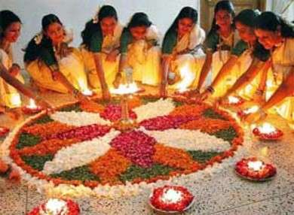 Image 17 and text (source: http://www.indiamarks.com/pookalam-the-onam-floral-rangoli)  
 **Assignment**

Collect some images of Pookalam and paste in the space provided below. (5 marks)

**Session 6- SLO 1 & 2**

**Mehendi designs, religious and cultural significances**

Mehndi for hands are most commonly used for celebrations as well as wedding ceremonies on the Indian subcontinent. They are very intricately designed as well as could incorporate a selection of patterns. If you look carefully at the layout on the hands of an Indian bride, you will certainly find the name of the couple interwoven in there. There is a lot of meaning that goes into mehndi designs for a bride-to-be. It is stated that the darker the color of the henna, the longer and also better the marriage will be. A deeper color also indicates that the bride-to-be will be treated well by her mother in law. And as long as she has the stain on her hands she will certainly not have to do any household chores at all. So, it is an excellent way for any new bride-to-be to aim for the darkest discolour possible. (Source: https://imehndi.com/henna-patterns-for-hands-the-traditional-body-artwork/)

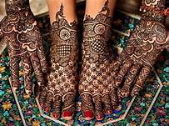 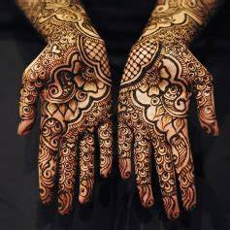 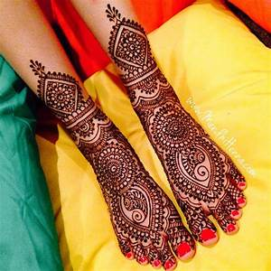

Image 18 (Source: https://images.search.yahoo.com/search/images)

**Assignment**

Answer the following questions briefly.

1. What is Mehendi?
2. What is the history behind Mehendi?
3. Comment on the significance of Mehendi in Hinduism.
4. What is the procedure of Mehendi application?

**Notes:**

**MODULE 5**

**Session 1 SLO 1&2**

**Nationalist School of Bengal Art- Introduction**

In Bengal, a new group of nationalist artists gathered around Abinandranatha Tagore (1871-1951). Abanindranath Tagore was a nephew of Rabindranath Tagore. This new group of painters rejected the art of Raja Ravi Varma as imitative and westernized. They declared that such a style was unsuitable for depicting the nation’s ancient myths and legends. This group felt that a genuine Indian style of painting must draw the inspiration from the non-western art tradition and should try to capture the spiritual essence of the East. So, these artists started doing experiments. They broke away from the tradition of oil painting. They broke away from the realistic style of Raja Ravi Varma and company artists. They turned to the inspiration to medieval Indian traditions of the miniature paintings and ancient art of mural paintings in Ajanta Caves. The paintings of Ajanta and Bagh, Mogul, Rajput and Pahari miniatures provided the models. The continuity of earlier traditions was sought to be maintained by borrowing from legends and classical literature like the Ramayana, the Mahabharata, Gita, and Puranas, the writings of Kalidasa and Omar Khayyam. At the same time, these artists were also influenced by the art of the Japanese artists who visited India at the time to develop an Asian Art movement. The initial artists are known for borrowing in profusion from Chinese calligraphy, Japanese colouring and Persian finish.

The above experiments called “avant garde” in artist’s parlance, led to the development of the Bengal School of Art. Avant Garde refers to the people or works that are experimental or innovative, particularly with respect to art, culture, and politics. One more immediate reason of rise of such artists was the widespread influence of the Indian spiritual idea to west. The Pilots of this school were Ernest Binfield Havel and Abanindranath Tagore. The other artists of this group were Gaganendranath Tagore, Asit Kumar Haldar, M.A.R Chughtai, Sunayani Devi (sister of Abanindranath Tagore), Kshitindranath Majumdar, Nandalal Bose, Kalipada Ghoshal, Sughra Rababi and Sudhir Khastgir.

Bengal school in painting was called the Renaissance School as well as the Revivalist School because this movement endeavoured for revival of the Indian ancient and medieval traditions. However, it is sometimes criticised because it took art back to the subject matter of ancient periods in an imitative manner without much creativity. The paintings were Simple and standard paintings with attractive colour scheme technique. Bright colours were not used in such paintings. The Bengal painters have made best possible efforts to bring in the rhythm, linear gracefulness and poise of Ajanta in their painting. Influence of Mughal and Rajasthan School can also be seen. Elegant and refined figures and the paintings exhibited skilfully exposed light and shade without any hardness. The artistic creed of this school was gradually challenged and new developments came about. A genuinely individual search for content and form led to a successful synthesis of Indian and European techniques. (Source: https://www.gktoday.in/gk/bengal-school-of-art/)

**Assignment**

Find out paintings by the artists belonging to the school mentioned above.

**Session 4**

**European influences (British) – Trends in painting – portrait, landscape and realistic**

**(Intensive Reading Session)**

The elite that dominated India was an opulent one with sophisticated tastes. It provided patronage for professional British painters on a scale that no other colonial community could match and included its own amateur artists of considerable ability. The pictorial record of British India from British sources is thus a very rich one. All these professional and amateur artists interpreted what they saw in terms of their own culture, their individual feelings, and their understanding of the relationship between their own society and the one in which they lived. In doing so, they helped British people at home to envisage the imperial order in India and in representing the Indian world in their own terms they expressed their sense that they understood that world, felt at home in it, and could dominate it.

Portraiture

In the second half of the Eighteenth Century a remarkable group of portrait painters moved to India. These painters looked for patronage among the European community in the major cities. To make a living, they painted portraits of East India Company officials, from the Governor-General downwards, or moved to Indian courts to paint princes, their relatives, and palace officials. But they also painted pictures for their own pleasure - of Indians, Indian landscapes, and exotic curiosities. There are a number of reasons why these portraitists did well in India. The British were increasingly aware of being involved in grand designs - commercial, military and political - in the subcontinent. Public buildings, if they wer to emulate the style of those at home, required paintings: the dignity of law courts, for example, would be enhanced by portraits of judges and chief justices. Many officials and officers sought to commemorate their period in India. Others wished to give presents to family or friends. Societies commissioned paintings of leading patrons and portraits of the leading grandees were painted to be presented to the royal court, leading aristocrats, or major institutions at home. The courts of the Indian princes were lucrative sources of work for similar reasons. There was a genuine fascination with the novelty of western art - its realism, perspective, and handling of colour - but, like the British, the indigenous rulers sought to enhance their style and importance through grand images. Moreover, a convention of present-giving developed whereby the Governor-General and other leading officials like the British Resident presented portraits of themselves and often received images of the Prince in return. Such portraiture was not merely an extension of European styles and conventions into a new environment. The subjects of paintings were, it is true, often placed in stylized architectural settings - against classical columns, a grand balcony, or hanging drapes - which could equally have worked in Europe. But others appeared against identifiable Indian scenes, featuring indigenous vegetation, backgrounds symbolizing the profession of the sitter (for example, a sepoy camp behind a British officer), or local buildings, both European and Indian. Even more interestingly, British subjects were sometimes painted with their Indian servants or with the 'bibis' (concubines) and their children. These portraits gave the artists further opportunities to dwell upon the beauty of carpets, clothing, jewellery, hookahs and other examples of Indian crafts, garden pavilions, and the like. By these means, the Indian portraits, like landscapes painted in the colonies, extended the range and taste of Eighteenth Century art. Indian portraits also acquired political significance. The paintings of Warren Hastings, Governor General from 1774 to 1785, were generally informal or, when he was painted with his family, were in the style of the English country parkland group portrait. Later in the century, however, portraitist were very much aware of painting a magnificent British court, almost seeking to match its Indian counterparts. Lord Mornington, later the Marquess Wellesley, was convinced that India could only be ruled from a great palace and in the grandest style. The many portraits he commissioned sought to convey this sense of a British court transplanted to the east and Wellesley was depicted in quasi-monarchical stance, magnificently robed and adorned. Later in the century the regal style became the standard for all the portraits of viceroys, now often accompanied by their vicerines, splendidly attired and bejewelled. From the 1840s painted portraits began to be replaced by photographs. Paintings were now restricted to the most senior of the British rulers in India and their function was almost exclusively a ceremonial and political one.

Landscapes

India extended the range of British landscape as well as of British portraiture. While some portraitists also painted landscapes, other painters arrived with the intention of specializing in that field. These landscape painters generally painted not only scenery, but also Indian architecture, palaces, forts, temples, and village scenes. In such paintings human figures often become incidental - providers of scale, indicators of the exotic, but not individually realized personalities. At the end of the Eighteenth Century Indian landscapes were painted according to the conventions of European landscape art, especially those of the 'picturesque'. Picturesque art placed its emphasis not on realistic representation, but on the creation of an arranged landscape that fulfilled certain expectations. Thus a variety of elements, often derived from on-the-spot sketching, would be brought together in a satisfying composition that met both a somewhat restrained sense of what was judged to be sublime and also the painter's idea of what India should look like. Picturesque conventions were to be remarkably durable in representations of India, lasting until the final quarter of the Nineteenth Century. India as depicted by the artists of the picturesque had some of what Europeans would have regarded as its exotic elements taken out of it. Indian architecture, for instance, was either shown in conventionally picturesque ruins or had its (to European eyes) startling lack of symmetry reduced to symmetrical forms. Nevertheless, these painters were enthralled by Indian vegetation, by the details of buildings and their sculpture, as well as by aspects of Indian ceremony. Though the publication of their works as engravings in major books of illustrations, they made available to a wider public some understanding of the appearance of India and above all of its architectural inheritance. They were the forerunners of the major Nineteenth Century projects for discovering, drawing and photographing the Indian architectural and sculptural traditions which helped to uncover the sequence and history of the more distant Indian past. The convention of the picturesque finally lost its hold on British representations of Indian scenes late in the Nineteenth Century, when it was replaced by what purported to be a more realistic style, often stressing what seemed to be an exotic India. (Source: https://www.britishempire.co.uk/art/artindia.htm)

**Notes:**

**The focus at this stage of the course is over group project work, where students should work as a team to collect information, edit to their need, and present it as a project work. The assessment should be based on the timely submission, individual participation, and quality of the content and genuineness of the final draft. The students could also be asked to make a PowerPoint presentation on their project. The project work would contain 20 marks.**

**Students can choose any ONE topic out of the following sessions mentioned in the course.**

**Session 3**

**Group Project**

Tracing the major ideas through paintings – Indian Village Life and nationalist themes.

Include several colour pictures as illustrations along with the factual details.

**Session 5**

**Group Project**

Submit a small spiral bound project in group on “Indo-Saracenic architecture” with history, factual details etc. Include several colour pictures as illustrations.

**Session 6**

**Group Project**

Submit a small spiral bound project in group on “Contemporary Indian Art”, with emphasis over Fusion of western style and Indian themes. Include several colour pictures as illustrations along with the factual details.